STANDARD OPERATING PROCEDURE FOR UPLOADING UTILIZATION CERTIFICATE (UC) THROUGH EAT (EXPENDITURE, ADVANCES AND TRANSFERS) MODULE ON PFMS PORTAL
- Login on PFMS portal …..’https://pfms.nic.in/’ by entering user id and password.
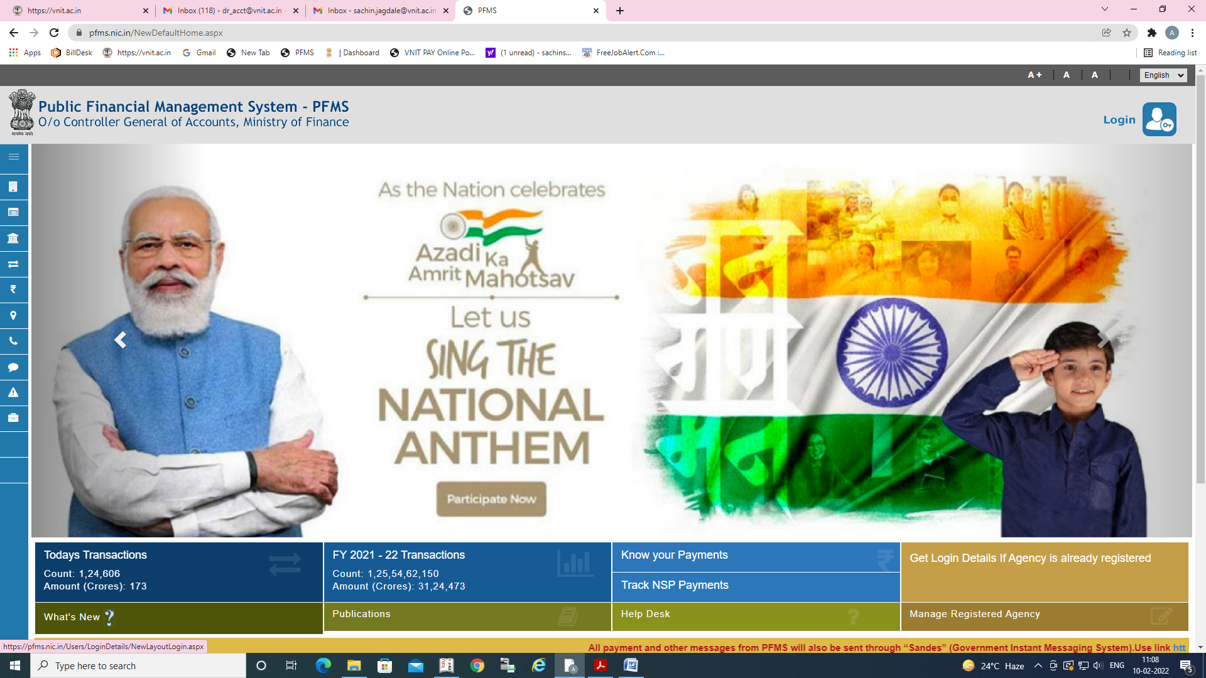

- Go to My Schemes View scheme components and note down ‘scheme components’ of relevant scheme, against which expenditure is to be captured in UC.
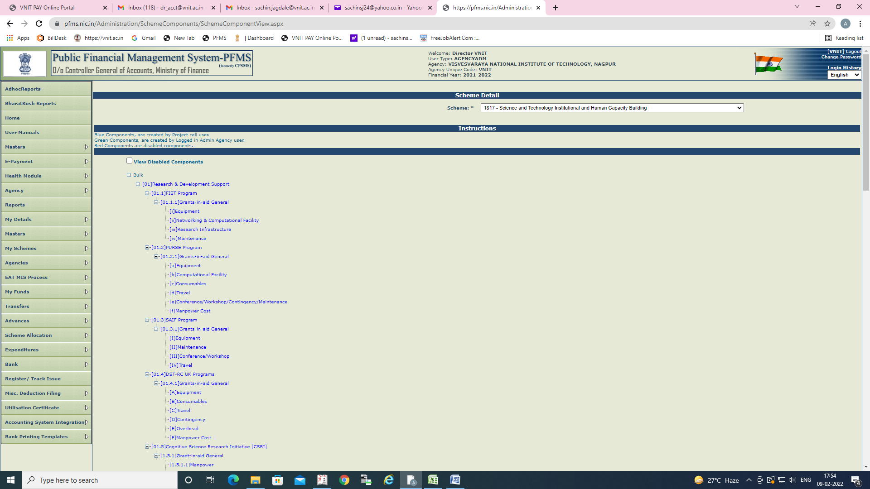

- Go to EAT MIS Process Exp/ Adv upload. Enter Scheme and appropriate Account Number and download excel template in which expenditure details are to be captured.
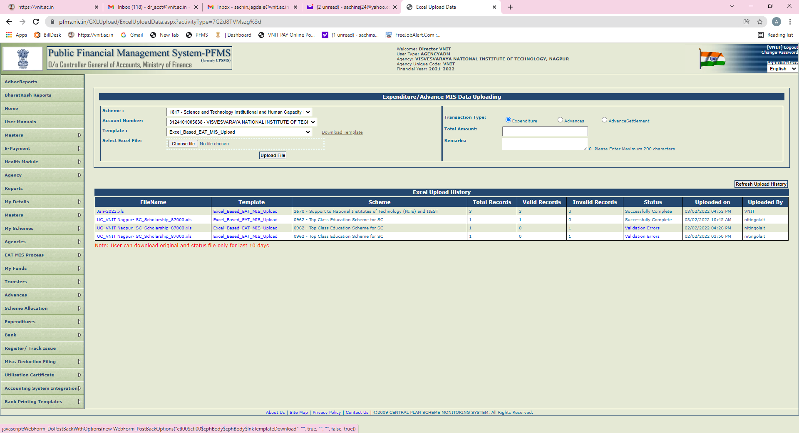

- Complete the excel sheet carefully, as indicated. Refer instructions in the second worksheet, if required and save the template.
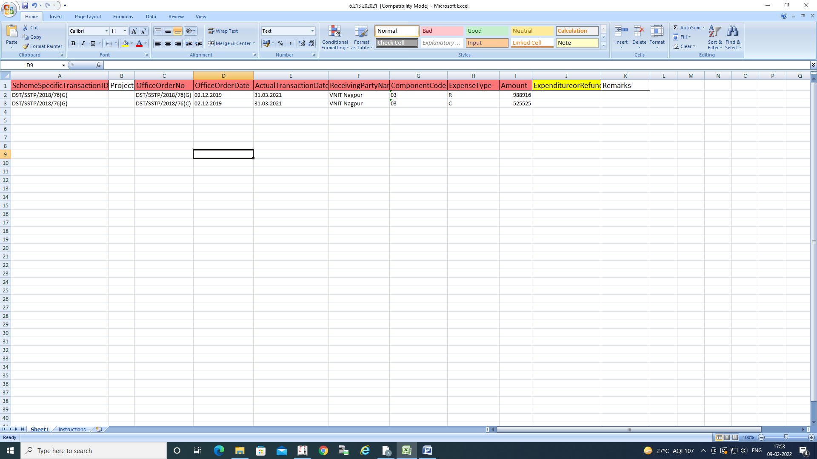

- Enter total amount as shown (should match with expenditure captured in excel template) and upload excel, using upload file tab.
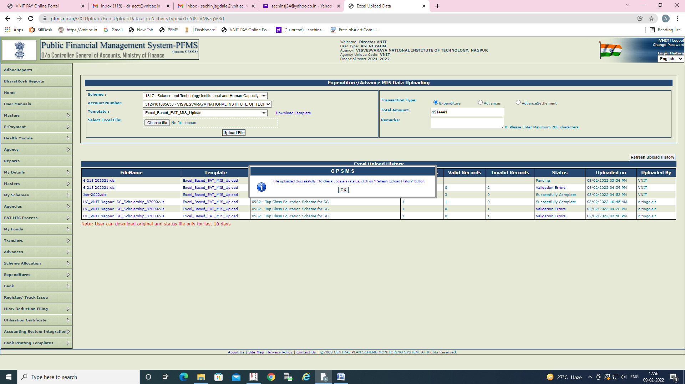

- Status of excel file should be ‘Successfully complete’. If there are validation errors, the excel sheet needs to be corrected and uploaded again.
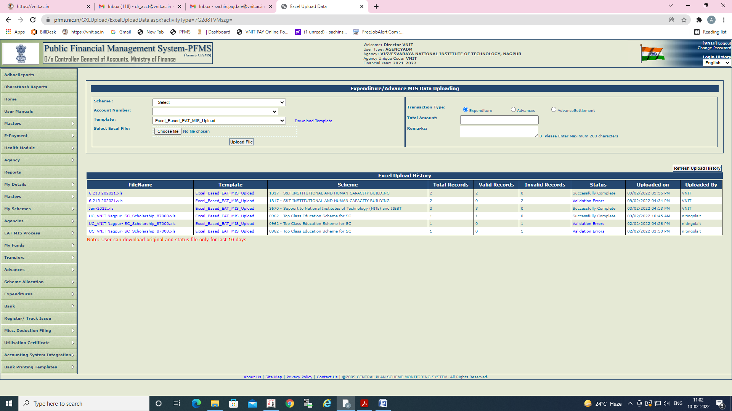

- Go to EAT/ MIS Process Manage Exp/ Adv MIS Data. Select Scheme and Bank Account and search for excel file uploaded. Enter maker remark as ‘ok’ and submit the file for approval.
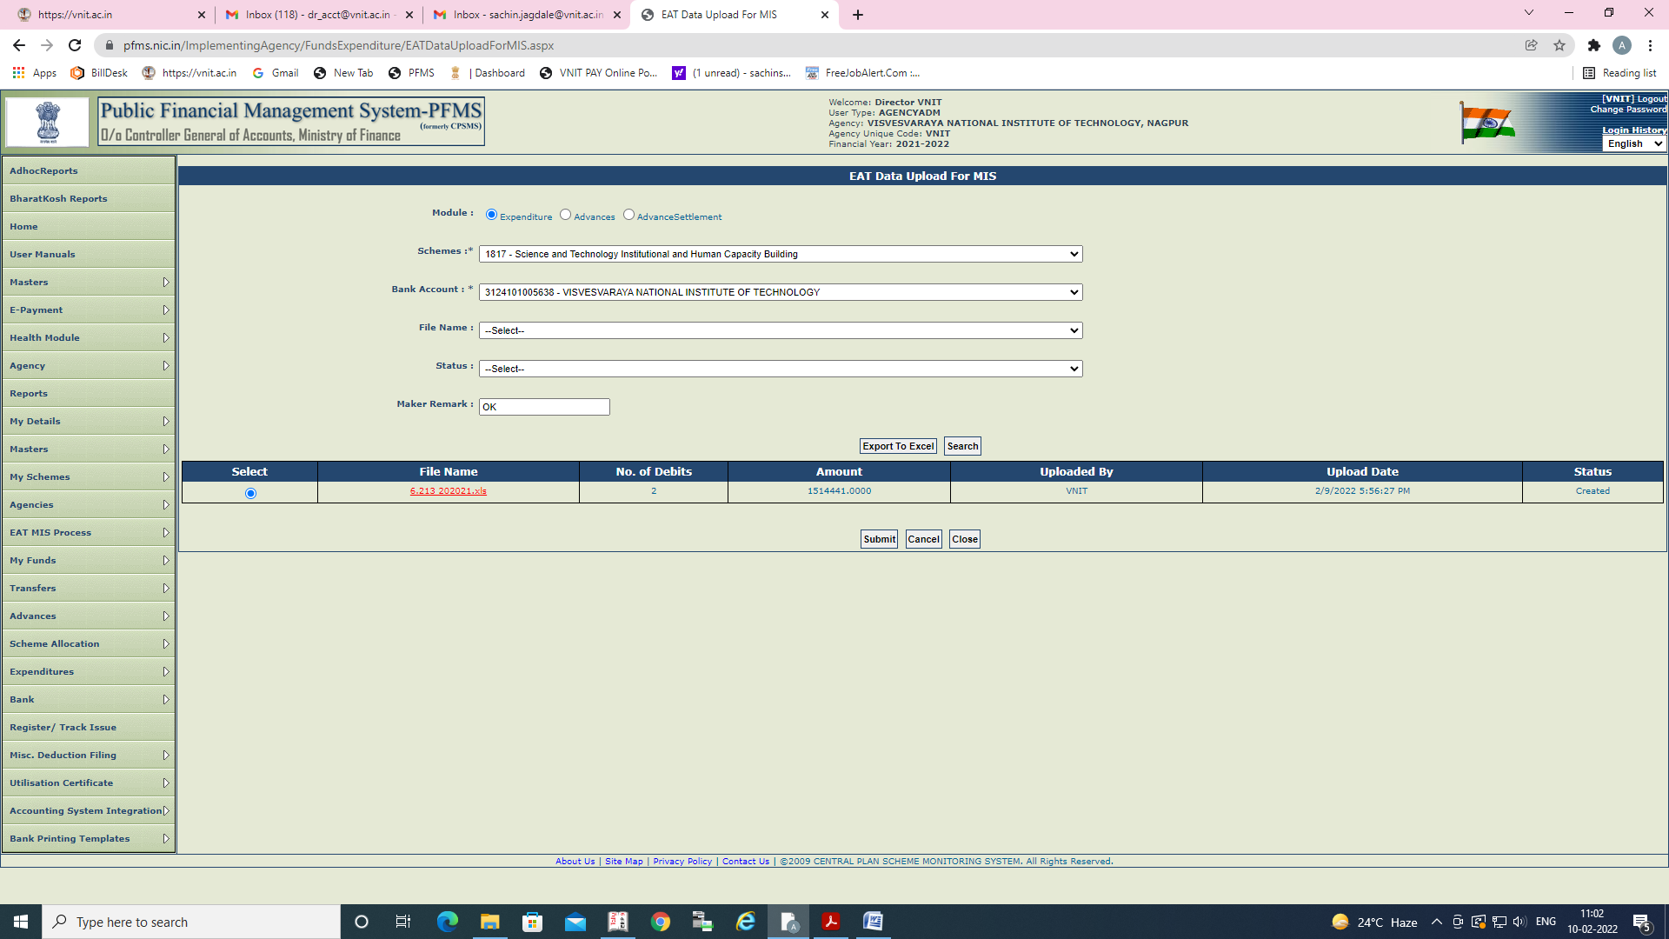

- Go to EAT/ MIS Process Manage Exp/ Adv MIS Data. Select Scheme and Bank Account and search for excel file uploaded. Enter checker remark as ‘ok’ and approve the excel file.

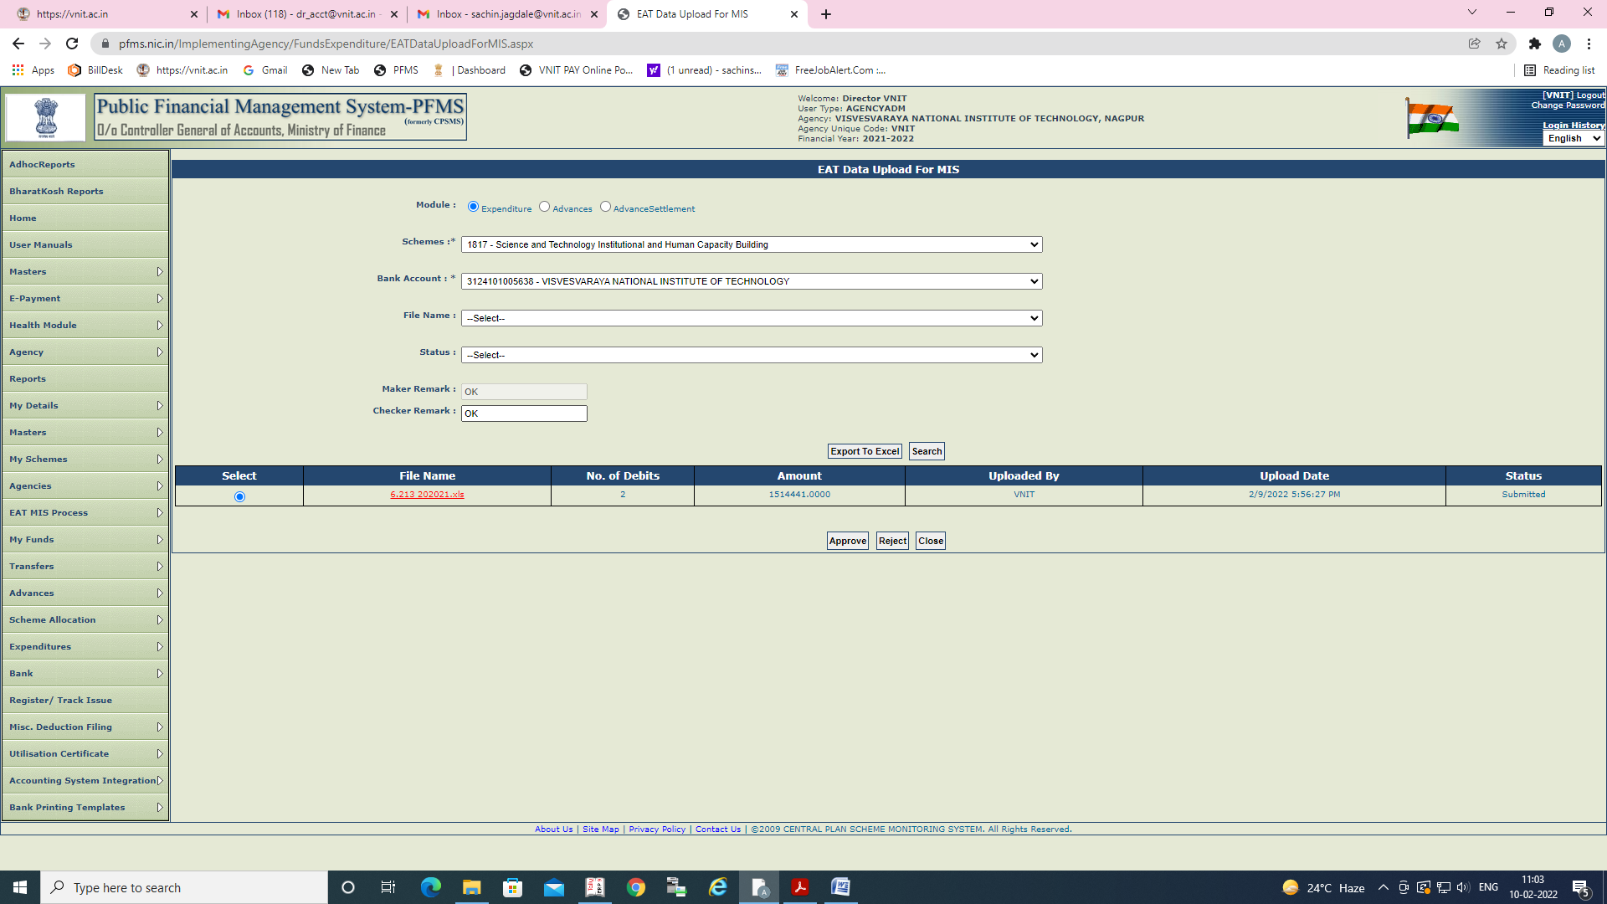

- Once the status of file is ‘Approved’ process of upload of UC is complete.




